
myfab
Laboratory Information Management System
Manual of the Myfab LIMS
Intiro Development
10/18/2010

Manual Myfab LIMS
Contents
General 4
Glossary 4
Lists/grids 5
Roles of the system 6
Use cases 6
Apply for access to LIMS 6
Apply for tool licence 6
To book a tool 7
Create a log connected to a booking or a tool 7
Send messages 7
Start page 8
New license applications and new user applications 9
News (Internal info page) 9
Booked Tools 10
My licenced tools 10
Tools 11
View Tool 11
My licensed tools 12
Book a tool 13
Apply for licence 15
All tools 16
Tool status 17
View bookings 19
My bookings 19
All bookings 20
Booking overview 20
Batches 21
Batch list 21
Log history by batch 21
Log history by tool 21
Log 22
Log status 22
Create a log on a booking / Log for booked tools 22
Create a log on a tool / Log without booking 24
Log history by tool 24
Log history by batch 24
Verify night shift booking 24
User 26
My Profile 26
My Statistics 30
Send message 31
User list 32

General

Glossary
Term | Description
Tool Id | A unique tool number. This Id is user defined.
Tool status | The status of a tool. The statuses are Available, Warning and Down.
Tool category | The tool type. All tools belong to one of the defined categories.
Tool down time | The hours the tool has been unavailable.
Tool document | Documents connected to the tool.
Booking | A booking on a specific tool.
Calendar | In the calendar the users can create/edit/view bookings. The calendar displays one week at a time.
Tool license | To book a specific tool the user must have a licence for that tool.
Licence application | Users that need to use (and book) certain tools must apply for a licence. The application is handled by the tool responsible/instructor.
Tool responsible | A user category. There are 1st and 2nd tool responsible. The users in this category grants licenses and is permitted to edit tool properties.
Practical coach | The practical coach is a user that has helped an applicant using a specific tool. The practical coach is a user who has licence for that specific tool.
Supervisor | When applying for membership in LIMS the applier can name his/her supervisor.
Instructor | A user category that instructs new users how to use tools and grants licenses.
Project | When booking a tool the user have to specify a project.
Batch | It is possible to add and edit batches, to be referenced to in log entries.
Night shift booking | Certain rules apply when booking tools outside daytime hours. (Optional)
Newsletter | Users belonging to one of advanced user roles can create/edit and send the newsletter.
Sitemap | A map over the structure of the website.
Profile | All users has a profile which can be edited by the users himself, email, password etc.
Process line(s) | Tools used in a process flow can be grouped using a process line.
External mail receivers | External (persons not active in the lab) mail addresses that will receive the newsletters.
Internal info page | The start page for LIMS. The page can be edited by advanced users.
Log | Electronic log book function or an entry in the electronic log book.
Log fields | It is possible to add/create custom log fields on every tool.
Fares and charges | Sets hourly rates, monthly fee etc. Used when handling invoices data.
Favourites | A menu that contains the selected favourites in the LIMS system. The favourites are user defined and set in the “My Profile” section.

Lists/grids
Lots of pages in the system are “List pages”, like User list, tool list, Booking list, project list, etc. Common for these pages are that they have a filter with options – depending of type of page.
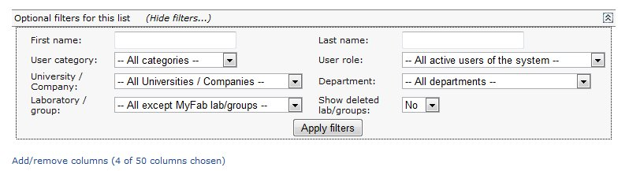
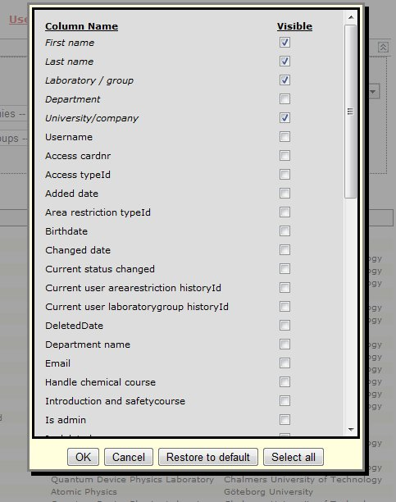
Some lists have a lot of viewable columns, a logged in user have the option to choose the columns to view. These settings are saved until the next time the user changes them.
Each list has some default columns that are showed the first time. You can always change back to “default” if you like (Restore to default button).

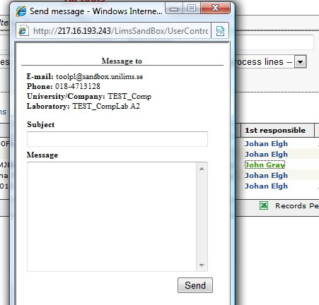

User in the lists is clickable. When clicked a small window with contact information is displayed. It is also possible to send a message.

Roles of the system

The system consists of primary and secondary roles.
Primary roles are: Administrator, User, Project manager, Project leader.
A user of the system must have one of these roles.
The user can also have an optional, secondary role: Instructor or Tool responsible.
An “Administrator” can see and do everything in the system. Booking rules do not apply, with a few exceptions.
A “User”, the most common role, is a standard user. He can See information, but not change or add/delete it.
A “Project manager” is basically a “User” who can add and manage projects, while a “Project leader” can manage projects, but not create any new.
The roles “Instructor” and “Tool responsible” opens up menus for editing tools, settings, and allow licensing of equipment for users.

Use cases
This section describes the workflow when performing some common tasks in LIMS.

Apply for access to LIMS
When a potential user needs access to LIMS, the user has to apply for membership.
Researchers, graduates, students and others that require access to the lab(s) can apply for membership from the start page by clicking the menu “Membership”.

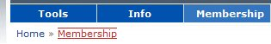
The steps necessary by the applying user are explained in the section Membership.
After a user has sent an application applying for membership in LIMS an administrator has to process the application, these steps are explained in the section Process application.

Apply for tool licence
If a user needs to book a tool, the user has to have a licence to use that particular tool.
The steps performed when applying tool licenses are described in the section Apply licence.
A tool responsible has to approve or decline applications, these steps are describe in the section Manage Licence applications.

To book a tool
The core of LIMS is the booking of tools. Booking a tool can be initiated from different sections in LIMS. The most common way of doing this is from the start page. This is done by clicking “Book” to the left of one of the tools displayed in the list My Licensed tools and thereafter perform a booking on that specific tool. The booking procedure is described in the section Book a tool.

Create a log connected to a booking or a tool
The recommended way is to create logs on bookings but some tools are not possible to book. In that case the user has to create a log directly on that tool.
Logging is usually performed from the start page in the list “My Bookings”.
How to create log on a booking see the section: Log for booked tools.
How to create log on a tool see the section: Log without booking.

Send messages
From within LIMS the user has the option to send messages to the other registered users in LIMS, how to do this is described in the section: Send Message.

Start page
Home
After a successful login the user is redirected to the start page shown below.
From the start page it is possible for the user to do the most common tasks in LIMS.
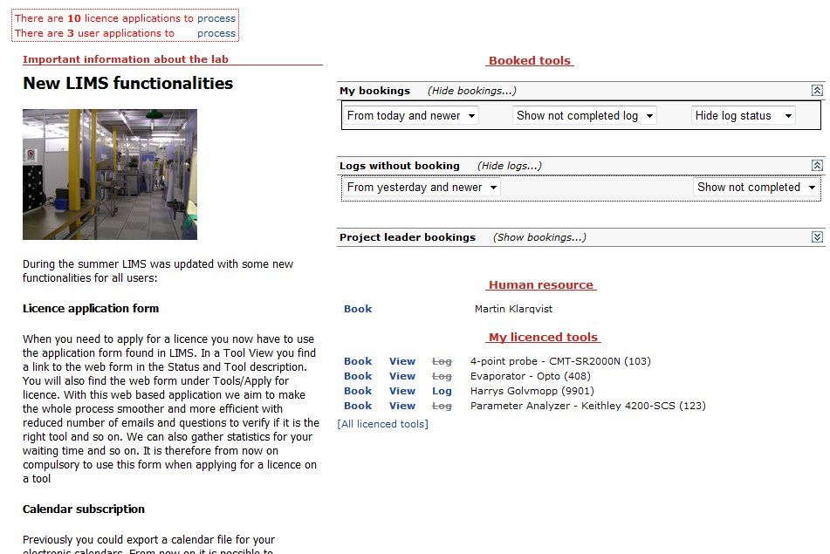
The start page contains of following sections:
- New license applications and new user applications
- News
- Booked tools, a list of booked tools
- Logs without bookings, a list of logs
- Project leader bookings, a list of bookings
- My licenced tools (Favorites), a list of tools
- My licenced tools (All licenced tools) , a list of tools

New license applications and new user applications
At the top of the page, both new licence applications(Tools) and new user applications(LIMS) are displayed.
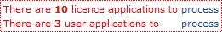
By clicking the links the user can manage/process these applications.
This section is only shown to the users who manages user applications or licence applications. The roles who manages applications are administrators and tool responsibles.

News (Internal info page)
The news are displayed under the header “Important information about the lab”.
Users with the role administrator, tool responsible, project manager and instructor are permitted to edit the internal info page/news page at Home » Advanced » Internal info page.
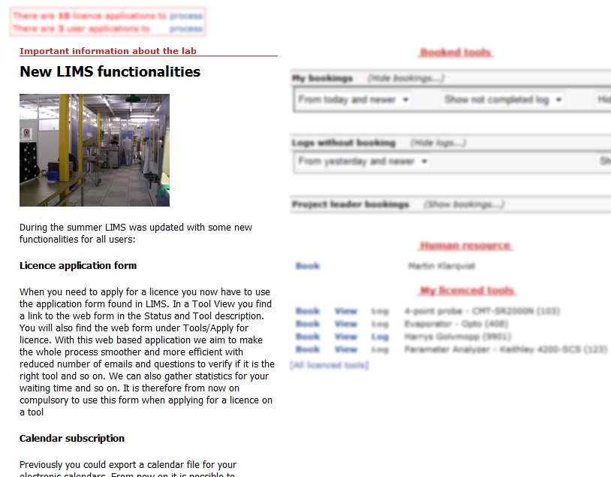

Booked Tools
This section of the start page displays booked tools and started log entries that are not connected to a booking. See picture below.
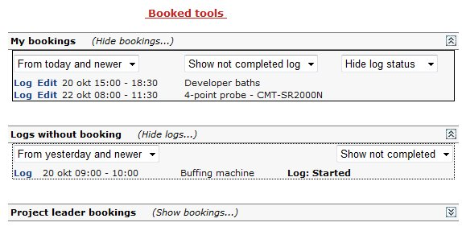
The user can edit the bookings and perform logging from any of the lists. This is done by clicking the links “Edit” (to edit a booking) and ”Log” (to create a log on a booking).

My licenced tools
This section lists the tools where the user has a licence. As default, only the tools selected as favorites are displayed. Favorite tools are selected/deselected at Home » Tools » My licenced tools.
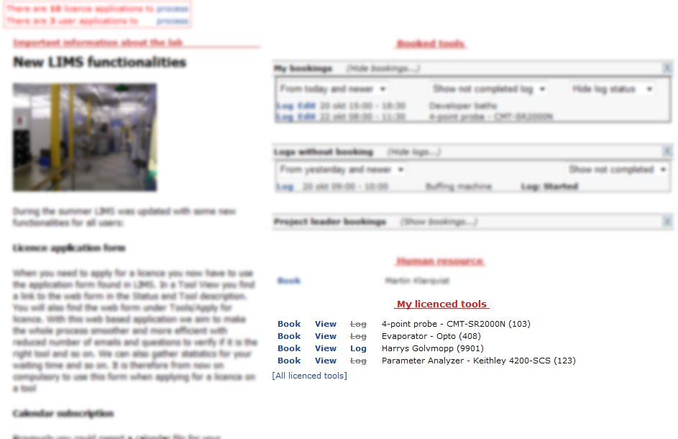
To see all licenced tools the user has to click the link “[All licenced tools]”. See picture below.
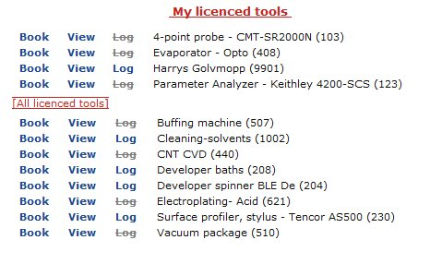
As seen above the user has the choice to perform bookings, perform logging or view the tool information in the list. This is done by clicking the links “Book” (to book a tool), “View” (to view a tool information page) and ”Log” (to create a log on a tool without booking).

Tools
Home » Tools
The “Tools” menu is accessible to all users of the system.
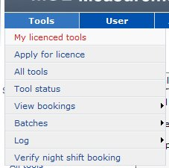

View Tool
This page is opened from several different tool lists like “All tools”, “Tool list”, “My Licensed tools” etc. View tool shows standard information, viewable to all users.
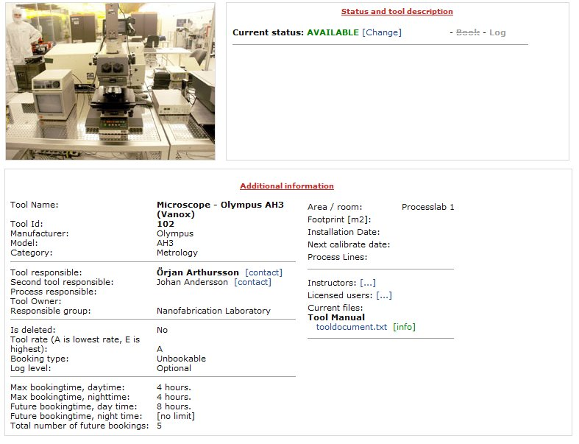

My licensed tools
Home » Tools » My Licensed Tools
The page displays a list of the tools where the user has licence. 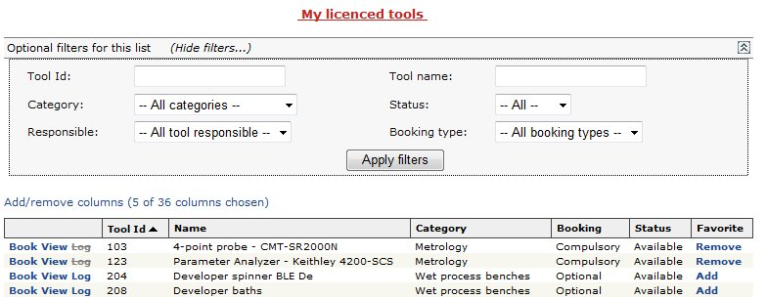
As seen above the user is able to perform bookings, perform logging or viewing the tool in the list. This is done by clicking the links “Book” (to book a tool), “View” (to view a tool) and ”Log” (to create a log on a tool without booking).
It is also possible for the user to add or remove a tool as a favourite tool. The favourite tools are seen at the top of the list “My Licenced tools” in the LIMS start page.
How to create log on a booking see the section: Log for booked tools.
How to book a tool is described in the next section: Book a tool.

Book a tool
From the list described above (My licenced tools) the user clicks the link “Book” to start booking a tool.
When clicking the link “Book” a calendar is displayed, all bookings are made in this calendar view. See picture below.
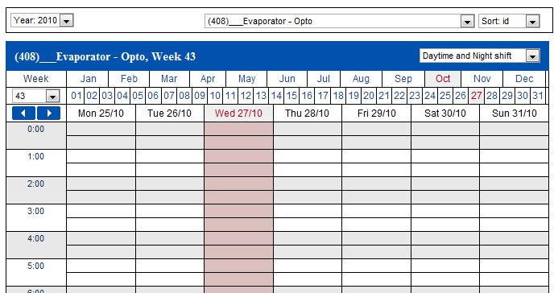
Booking is made by clicking the start time and end time in the calendar. See picture below.
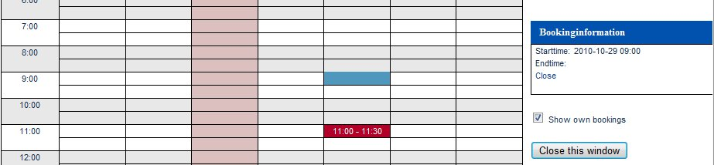
After clicking the end time a popup is displayed where the user selects project, batch no (optional) and confirms the booking by clicking the button named “Book”. See picture below.
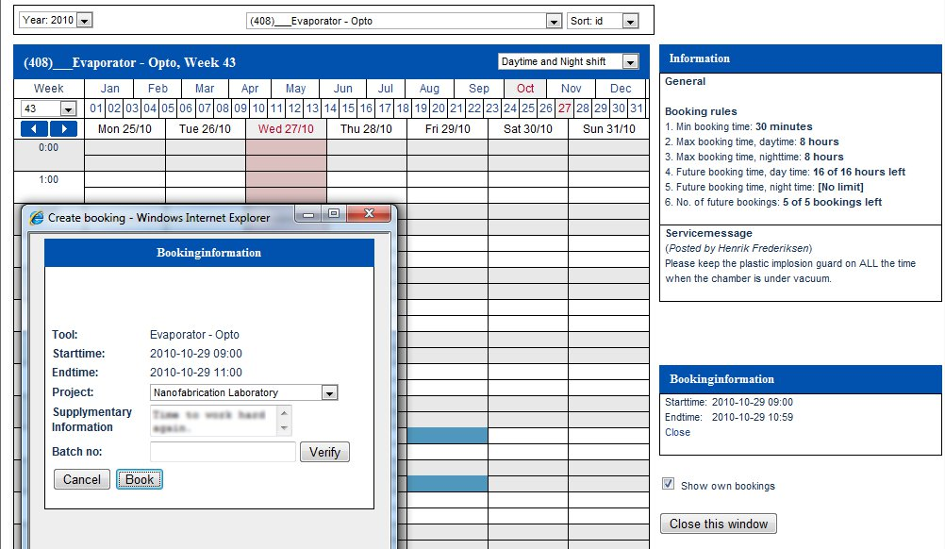
After confirmation the booking is displayed in the calendar as shown in picture below.
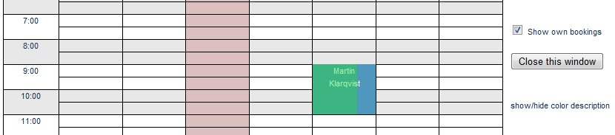
By selecting another tool at the top of the page the user can book several tools at once.
The bookings for the selected tool are displayed in blue. Other tool bookings made by the user are displayed in green. See pictures below.
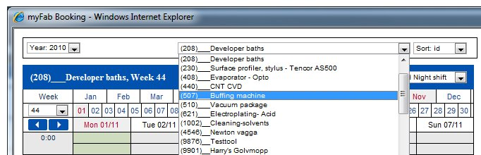

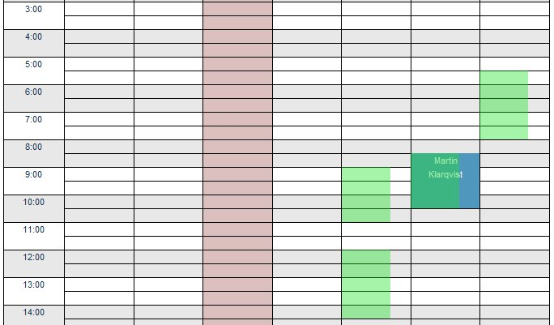
The easiest way to edit a tool booking is simply to click the link “Edit” from the list Booked Tools at the Start page.
There are a number of rules and settings affecting the booking of tools. These are described in the section Booking in LIMS.
Apply for licence
Home » Tools » Apply for licence
In this page any user can apply for a tool licence.
The three different dates are suggestions for the necessary overhaul done by a tool responsible or an instructor. The practical coach is another user who has licence for that tool. The practical coach must be a user that has helped the applicant using the specific tool.
The application is sent by mail to 1st or 2nd tool responsible and all instructors for that tool. When the license is confirmed by a tool responsible or instructor the user receives a “driving” license for that tool. This means that the user is allowed to book and use that tool.
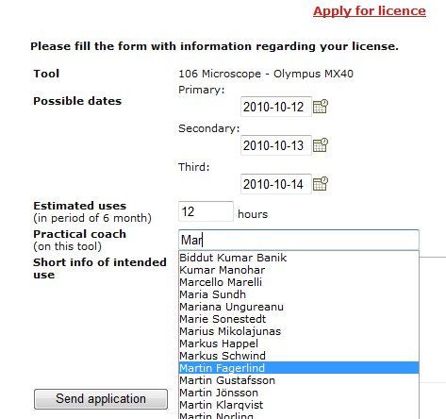

All tools
Home » Tools » All tools
This page lists all tools registered in the system. It is possible to do some filtering to narrow down the number of tools displayed.
To book a tool click the link “Book”.
To view the details click the link “View”.
To perform logging, click the link “Log”.
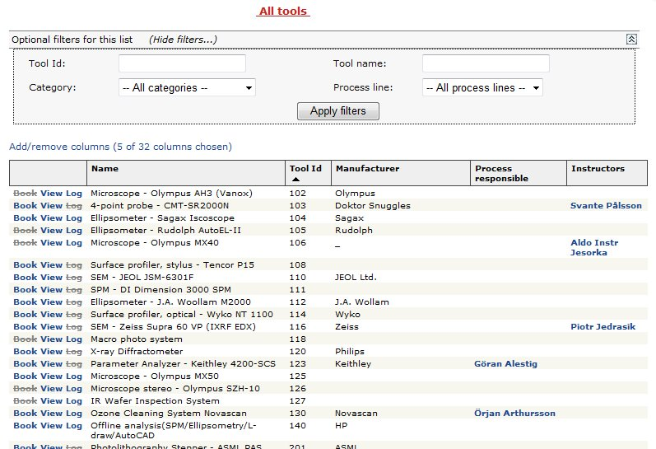

Tool status
Home » Tools » Tool status
This page lists all tools registered in the system displaying their current status.
It is possible to do some filtering to narrow down the number of tools displayed.
Users with proper permissions can change the status for a tool by clicking the link “Change status”.
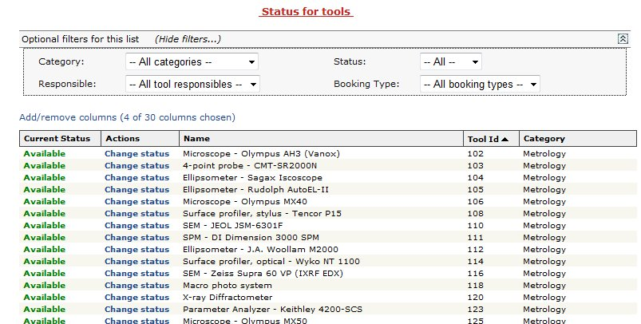
The popup window used to change tool status, see picture below.
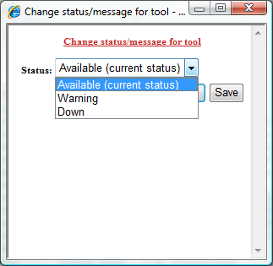

When the user changes the tool status it will probably affect the bookings made on that tool.
Status change | Effect
Available -> Warning | When a booking is made a warning message will be displayed to the user.
Available/Warning -> Down | All future bookings will be deleted. If a booking spans into the down period that booking will be shortened to the nearest available ½ hour.
Down -> Available/Warning | If licenced users to that tool has activated e-mail notifications in “My Profile” they will receive a notification e-mail when a tool status changes from “Down”.
The setting in that activates e-mail notification, see picture below.
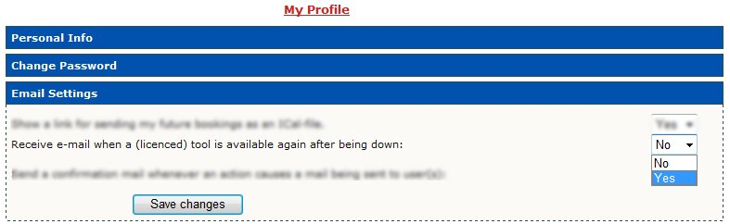

View bookings
Home » Tools » View Bookings
This part of the application give the users an overview of their own bookings and the opportunity overview other bookings as well.
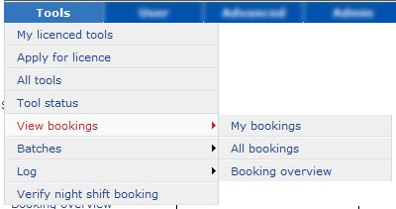

My bookings
Home » Tools » View Bookings » My bookings
The page is an overview of the bookings made by the user. The listed bookings can also be edited, viewed and deleted.
To edit a booking click “Edit” in the list.
Bookings can be deleted by selecting booking(s) and pressing the button “Delete checked bookings”.
The user can also perform logging by clicking the link “Log”.
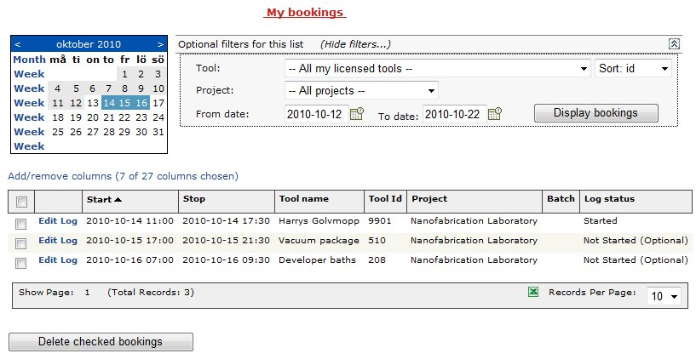

All bookings
Home » Tools » View Bookings » All bookings
The page lists all bookings for a tool AND/OR a project during a period of time.
In the example below the user is listing all bookings in the project “Nanofabrication Laboratory”.
The listed bookings can also be edited, viewed and deleted.
To edit a booking click “Edit” in the list.
Bookings can be deleted by selecting booking(s) and pressing the button “Delete checked bookings”.
The user can also perform logging by clicking the link “Log”.
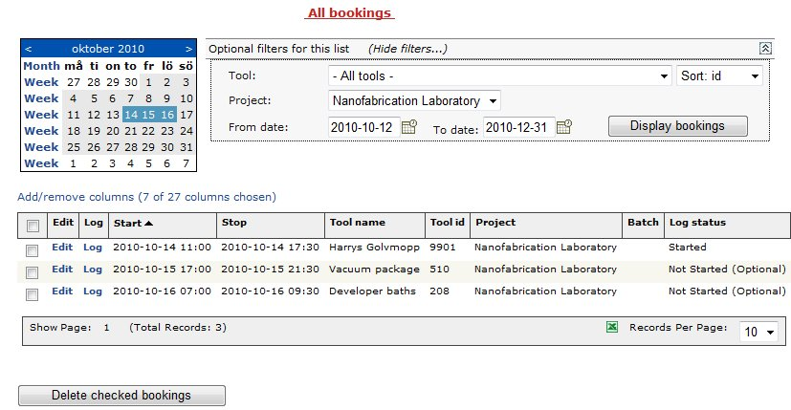

Booking overview
Home » Tools » View Bookings » Booking overview
This page displays an overview of bookings the selected date.
It is possible to see all bookings the selected day by setting the filter seen below.
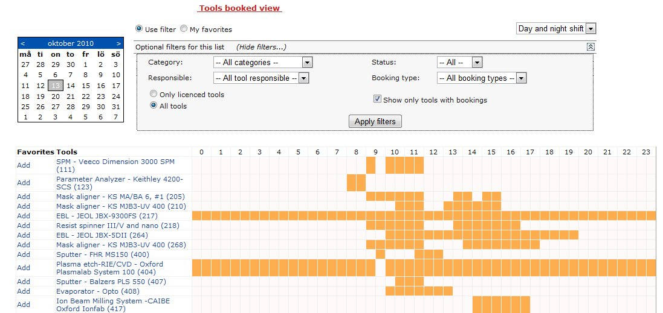

Batches
Home » Tools » Batches
In this section the users have the possibility to view and manage batches.
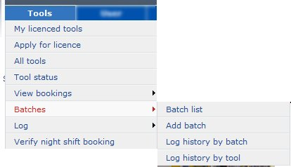

Batch list
Home » Tools » Batches » Batch list
The page lists batches in the system. By changing the filter it is possible to see all batches.
The user has the possibility to edit/change the batch by clicking the link “edit”.
It is also possible to display the log history by clicking the link “History”.
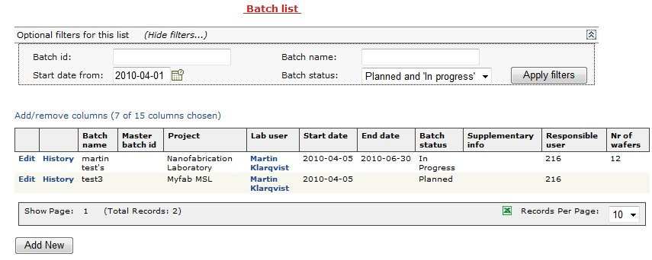

Log history by batch
Home » Tools » Batches » Log history by batch
This page lists all log entries where the user has entered a batch number/name in that specific log entry.
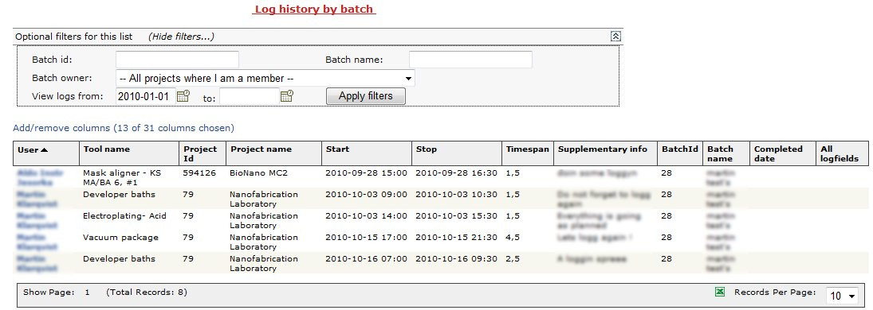

Log history by tool
Home » Tools » Batches » Log history by tool
This page lists log entries by a specific tool where the user has entered a batch number/name in that specific log entry.
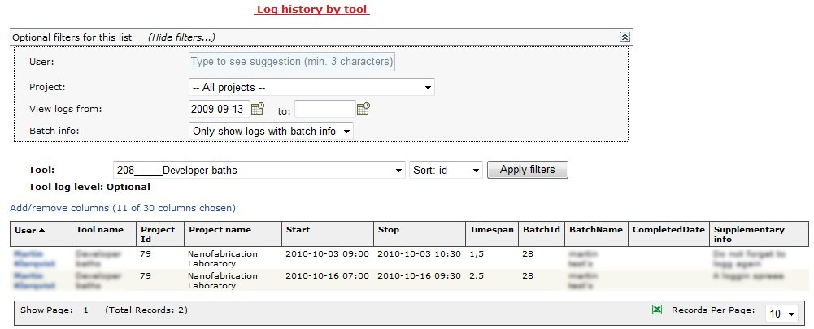

Log
Home » Tools » Log
This section provides the user with a summary / overview of the logs created.

Log status
Home » Tools » Log » Log Status
This list displays logs and their status, see picture below.
Only the users own bookings are displayed in the list.
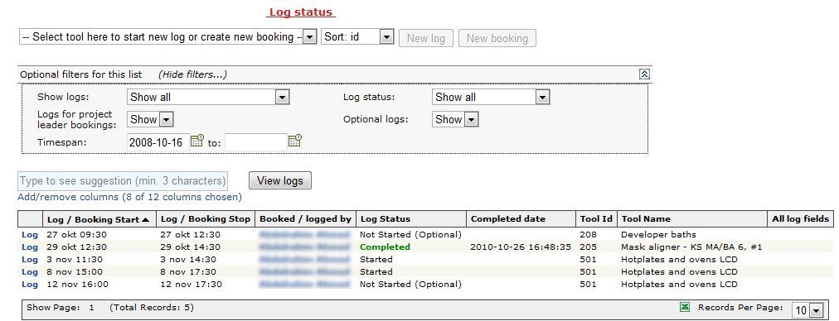
The user can create a log or continue logging by clicking the link “Log”.
In this page the user also has the option to create logs directly on a tool or to create a booking. See the picture below. To create a booking on the selected tool just press the button “New booking” and to create a log just press the button “New log”.

Create a log on a booking / Log for booked tools
The user can create a log or continue logging by clicking the link “Log” in the list displaying
When creating a new log or continues logging on a booking the page below is displayed.
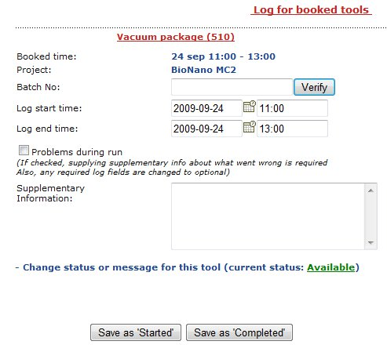
When pressing the button “Save as ‘Started’” the log is marked “Started” and not closed, it is possible to perform more logging on that booking. If the button “Save as ‘Completed’” is pressed the log on that booking is marked “Completed”, logging is not supposed to continue on that booking.

Create a log on a tool / Log without booking
In this page the user also has the option to create logs directly on a tool or to create a booking. See the picture below. To create a booking on the selected tool just press the button “New booking” and to create a log just press the button “New log”.

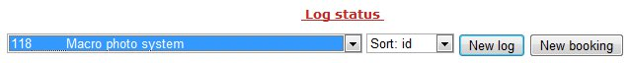
When creating a log on a tool without booking the page below is displayed.
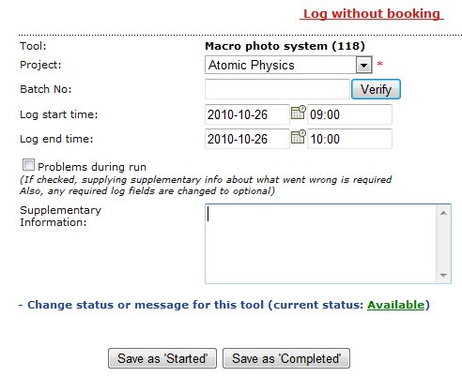
The functionality of the buttons is the same as for Log for booked tools.

Log history by tool
Home » Tools » Log » Log history by tool
Same as described in section Log history by tool.

Log history by batch
Home » Tools » Log » Log history by batch
Same as described in section Log history by batch.

Verify night shift booking
Home » Tools » Verify night shift booking
This page helps users to find lab buddies during night shift.
Users search for bookings during the period of their lab stay.
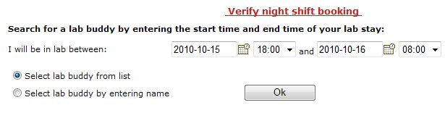
If there are bookings during selected period they will be shown in the list.
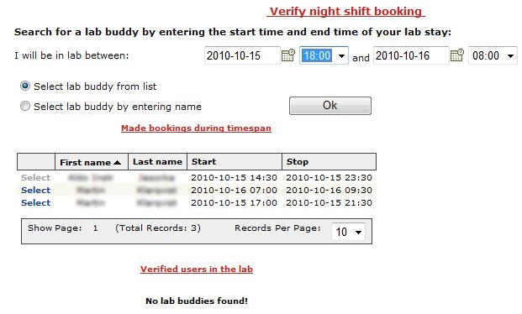
A lab buddy is selected by clicking the link “select”.
After selecting a lab buddy the user must confirm/complete the verification and optionally supply some extra information.
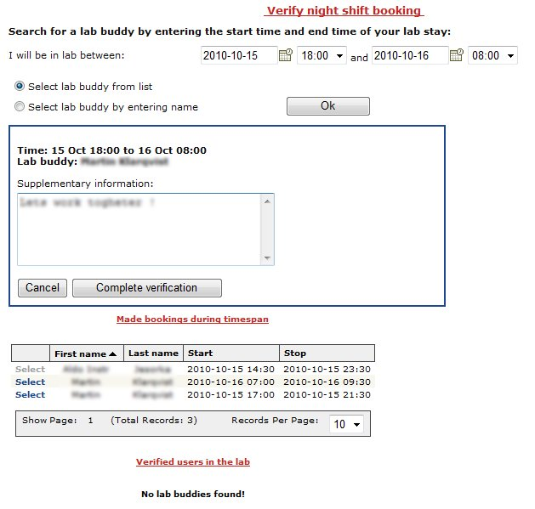
An e-mail is sent to the selected lab buddy upon confirmation.
The confirmed lab buddy is shown in the list “Verified users in the lab”, see picture below.
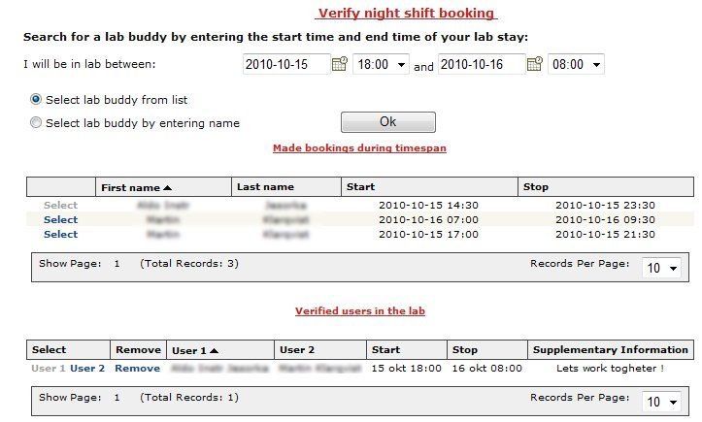
User
Home » User
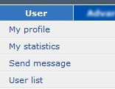
All users have access to the “User” menu.
In this section it is possible to:
- View and edit my own profile
- View some statistics over my bookings.
- Send messages to other users
- View some user information of other users.

My Profile
Home » User » My Profile
There are five sections in “My Profile”, “Personal Info”, “Change Password”, “Email Settings”, “User Settings” and “Favorites”. In the different sections the logged in user can view and edit his/her settings.

Personal Info
To change the settings, simply edit the fields and press the button “Save Changes”.
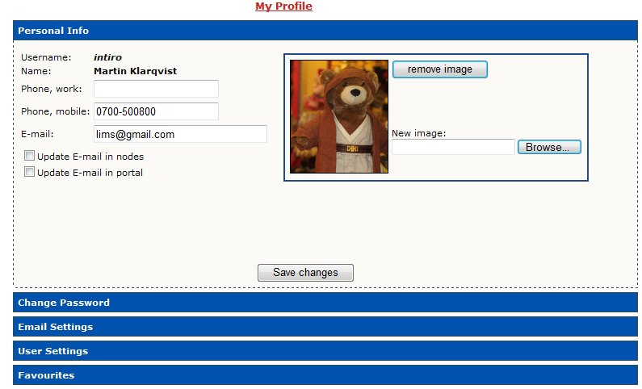

Change Password
In this section the user can change the password by entering a new password and press the button called “Change Password”. If the checkbox called “Update password in nodes” is checked the password change is made in other connected LIMS nodes as well. If the checkbox called “Update password in portal” is checked the password will be updated in the portal as well.
It is possible to distribute the current password to the other LIMS-nodes by clicking the link “Set this password as password in other nodes”. In this case it is not necessary to change the password, just click the link and the password will be the same in all LIMS-nodes.
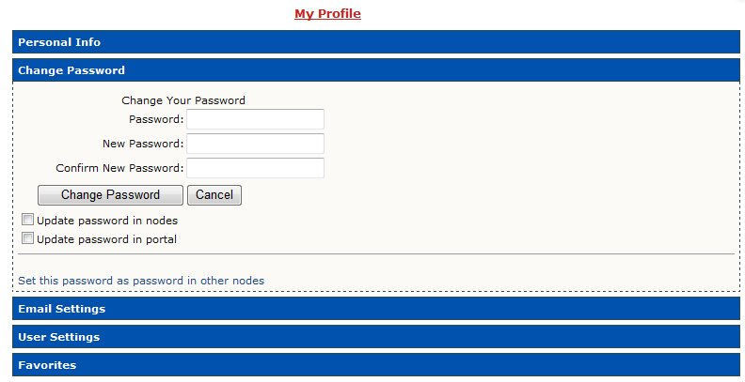

Email settings
This section allows the user to change the personal Email settings.
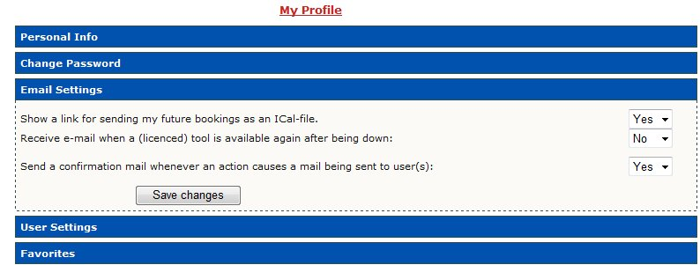

User Settings
This section allows the user to change settings:
- My default project when booking
- Use simultaneous booking windows.
When booking in the calendar, more than one booking window can be open at a time.
- Default timeout for login.
The time before the user will be logged out due to inactivity.
- Use iCalendar-feed.
If checked the user gets a link that can be imported to a calendar.
By clicking the link “Show” the link to the iCalendar feed is shown.
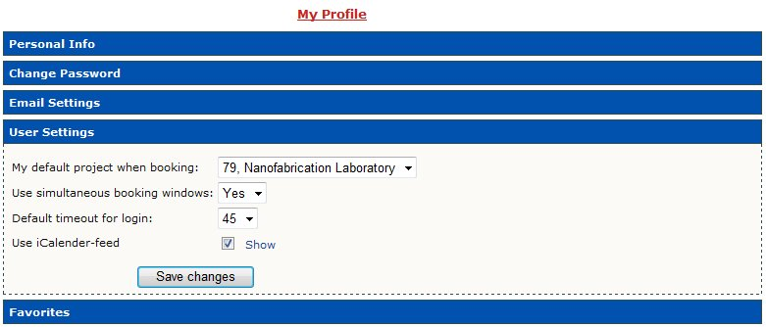
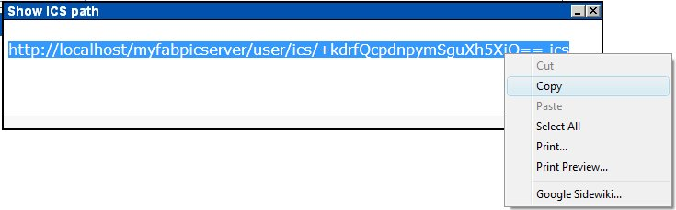
By copying the link into a calendar that supports iCalendar (like the Google calendar) the user’s future bookings is shown in the calendar.
See picture below.
iCalendar Example 1 – MonoCalendar:
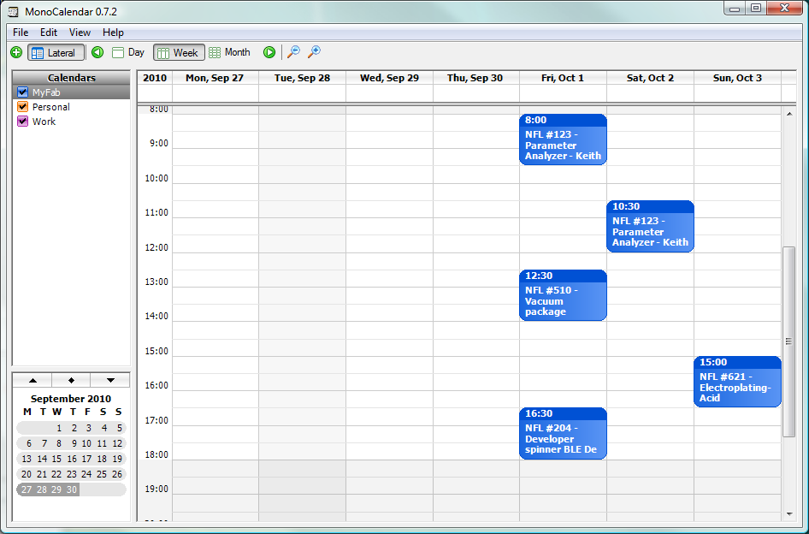
iCalendar Example 2 - Google Calendar
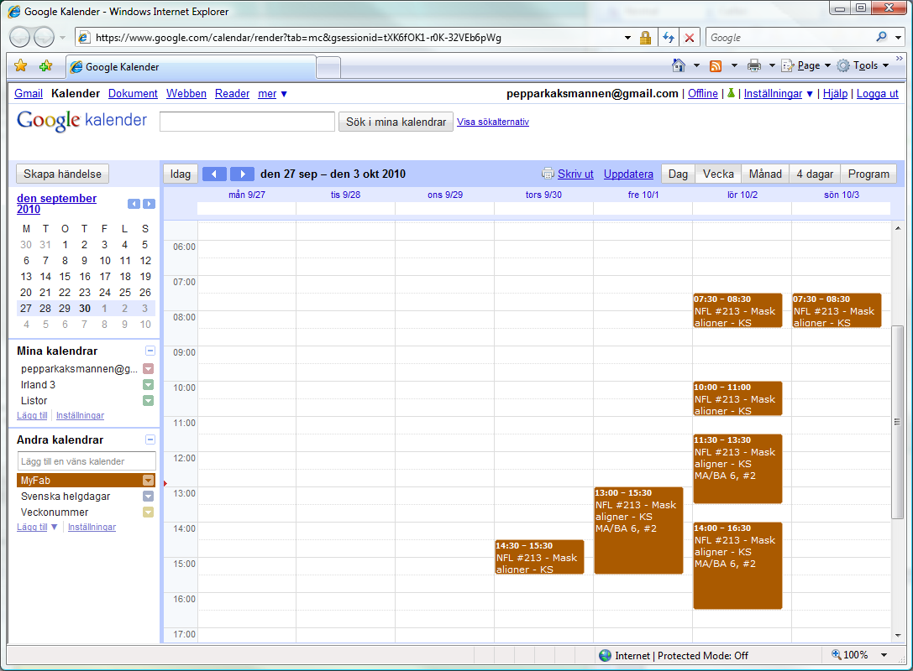

Favorites
Favorites are created by checking different sections, see picture below to the left.
The selected sections is displayed as “Favorites” in the left hand menu, see picture to the right.
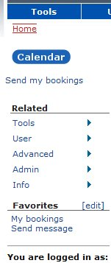
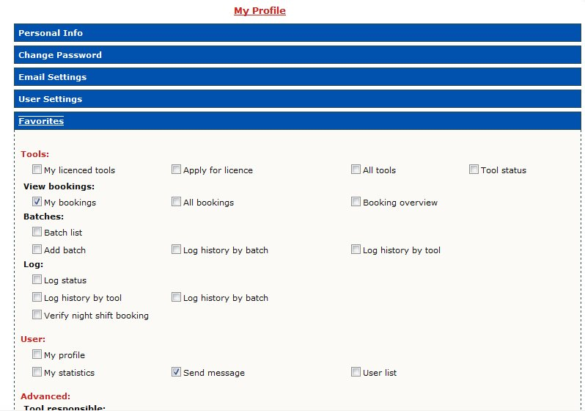

My Statistics
Home » User » My Statistics
Statistics is presented to the user, see picture below.
The data displayed is a summary of the bookings performed by the logged in user during selected period.
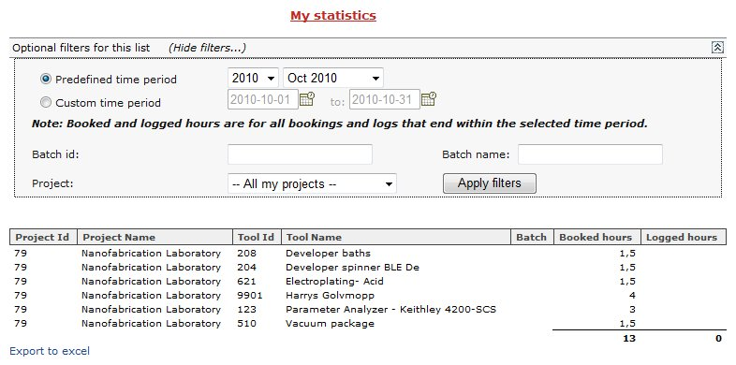

Send message
Home » User » Send message
This page enables the user to send messages to other users registered in LIMS.
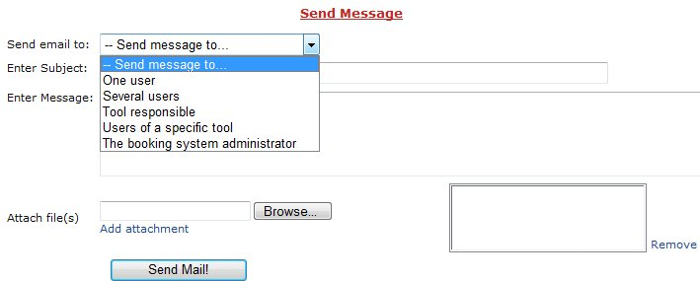
The user first selects a recipient type in the drop down box.
When a recipient type is selected the page changes appearance and the user is presented with different options:
- One user.
A text field is shown.
Use the text field to enter the name of a user.
The text field will display a list of users when entering the name.
- Several users.
Displays a list of all users with filtering options.
- Tool responsible.
Displays a drop down box containing all tools.
- Users of a specific tool.
Displays a drop down box containing all tools.
- The booking system administrator.
After selecting recipient type the user selects the actual recipient(s) and enters subject, the message text and attaches file(s).

User list
Home » User » User list
Displays users in LIMS, all users can be listed here.
